Name _________________________________ Date ________________________
Chapter 15: Racial, Economic, and Political Change

True/False
Indicate whether the statement is true or false.

____ 1. Matthew Perry was the chief lawyer of the NAACP in South Carolina.

____ 2. South Carolina integrated its schools in 1956 to be in compliance with Brown v. Education.

____ 3. Medicare was founded under President John F. Kennedy.

____ 4. In 2012, over half of the electricity used in South Carolina is generated from coal.

____ 5. The campaign of 1970 was the last time race was a major issue in South Carolina.

Multiple Choice
Identify the choice that best completes the statement or answers the question.

____ 1. Who was one of the founders of citizens’ schools to teach literacy and train citizens to vote?
a. | Septima Poinsette Clark
b. | Nikki Haley
c. | Martin Luther King, Jr.
d. | Jackie Robinson

____ 2. What group organized the freedom rides?
a. | CCC (Civilian Conservation Corps)
b. | CORE (Congress of Racial Equality)
c. | NAACP (National Association for the Advancement of Colored People)
d. | SCLC (Southern Christian Leadership Conference)

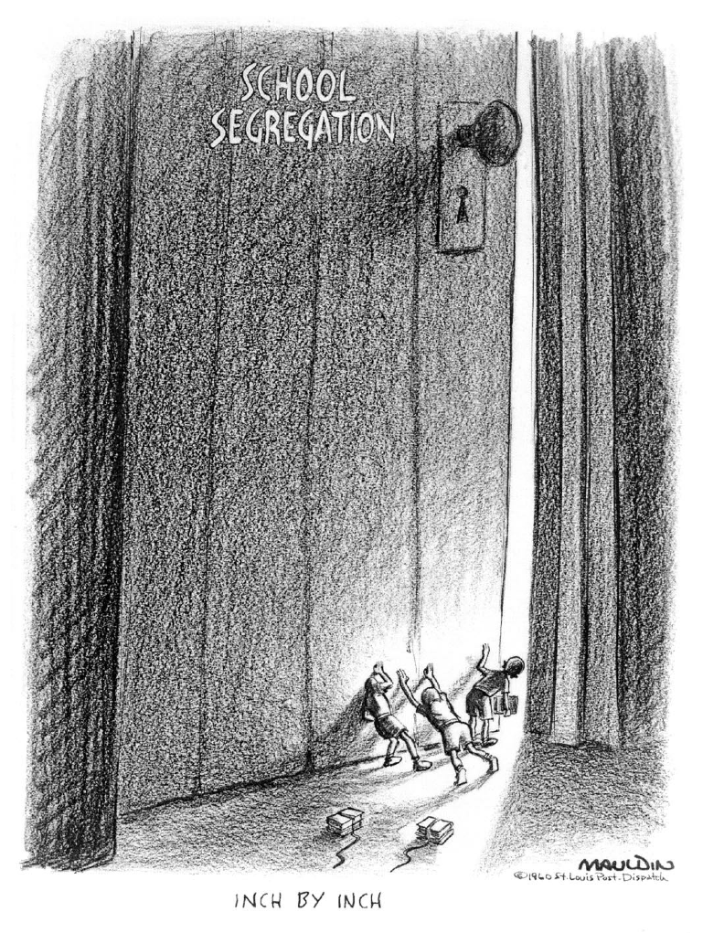
____ 3. What is the subject of the political cartoon?
a. | discrimination
b. | the Ku Klux Klan
c. | segregation
d. | voting rights

____ 4. During what time was the cartoon probably drawn?
a. | 1940s
b. | 1950s
c. | 1960s
d. | 1970s

____ 5. What title best represents the subject of the cartoon?
a. | Change is a Long, Slow Process
b. | Education Opens the Door to the Mind
c. | Students Take Early Steps to Graduation
d. | Learning Doesn’t End at the Schoolhouse Door

____ 6. What Supreme Court case ordered states to establish unitary, integrated school systems?
a. | Brown v. Board of Education
b. | Edwards v. South Carolina
c. | Green v. New Kent County
d. | Plessy v. Ferguson

____ 7. What was the mission of the State Development Board created in 1954?
a. | provide training for the state’s workers
b. | get business from other states and countries
c. | turn rural, non-productive land into tourist attractions
d. | develop a first-class educational system

____ 8. In the 1960s, what two cities took the lead in seeking European manufacturers to locate in South Carolina?
a. | Spartanburg and Greenville
b. | Greenville and Columbia
c. | Charleston and Aiken
d. | Beaufort and Charleston

____ 9. For which Republican presidential candidate did Strom Thurmond change parties in order to support?
a. | George Bush
b. | Barry Goldwater
c. | John McCain
d. | Ronald Reagan

Completion
Complete each statement.

1. ________________ means to be on property without permission.

2. If someone is aggressive or radical, he or she is said to be ___________________.

3. When legislative representatives are rearranged to meet population changes, the process is known as _______________________.

4. If something is obvious, it is said to be _______________________.

5. One of the two steps toward equality for all people in the Civil Rights Act of 1964 was the provision that outlawed discrimination in ________________________________.

Matching

Match the governor with the statement describing something that occurred during his administration.
a. | James B. Edwards | d. | Donald S. Russell
b. | Ernest F. Hollings | e. | John C. West
c. | Robert E. McNair

____ 1. resigned as governor to take a vacant seat in the U.S. Senate

____ 2. established Commission on Human Affairs

____ 3. established an educational television system

____ 4. overhauled the Constitution of 1895

____ 5. Education Finance Act provided more funds to poor schools

Essay

1. Describe the non-violent types of protests used during the civil rights movement.

Chapter 15: Racial, Economic, and Political Change
Answer Section

TRUE/FALSE

1. ANS: T PTS: 1 DIF: Knowledge REF: Chapter 15 Section 1
TOP: Civil Rights

2. ANS: F
True integration in South Carolina did not occur until 1970.

PTS: 1 DIF: Application REF: Chapter 15 Section 1
TOP: Civil Rights

3. ANS: F
Medicare was founded under President Lyndon B. Johnson.

PTS: 1 DIF: Knowledge REF: Chapter 15 Section 1
TOP: Changing Society

4. ANS: F
In 2012, over half of the electricity used in South Carolina is generated in nuclear plants.

PTS: 1 DIF: Knowledge REF: Chapter 15 Section 2
TOP: Economic Change

5. ANS: T PTS: 1 DIF: Knowledge REF: Chapter 15 Section 3
TOP: Political Change

MULTIPLE CHOICE

1. ANS: A PTS: 1 DIF: Knowledge REF: Chapter 15 Section 1
TOP: Civil Rights

2. ANS: B PTS: 1 DIF: Knowledge REF: Chapter 15 Section 1
TOP: Civil Rights

3. ANS: C PTS: 1 DIF: Analysis REF: Chapter 15 Section 1
TOP: Civil Rights

4. ANS: C PTS: 1 DIF: Analysis REF: Chapter 15 Section 1
TOP: Civil Rights

5. ANS: A PTS: 1 DIF: Analysis REF: Chapter 15 Section 1
TOP: Civil Rights

6. ANS: C PTS: 1 DIF: Analysis REF: Chapter 15 Section 1
TOP: Civil Rights

7. ANS: D PTS: 1 DIF: Application REF: Chapter 15 Section 2
TOP: Economic Change

8. ANS: A PTS: 1 DIF: Knowledge REF: Chapter 15 Section 2
TOP: Economic Change

9. ANS: B PTS: 1 DIF: Knowledge REF: Chapter 15 Section 3
TOP: Political Change

COMPLETION

1. ANS: Trespass

PTS: 1 DIF: Knowledge REF: Chapter 15 Section 1
TOP: Vocabulary

2. ANS: militant

PTS: 1 DIF: Knowledge REF: Chapter 15 Section 3
TOP: Vocabulary

3. ANS: reapportionment

PTS: 1 DIF: Knowledge REF: Chapter 15 Section 3
TOP: Vocabulary

4. ANS: blatant

PTS: 1 DIF: Knowledge REF: Chapter 15 Section 3
TOP: Vocabulary

5. ANS:
employment opportunities
access to public accommodations

PTS: 1 DIF: Comprehension REF: Chapter 15 Section 1
TOP: Civil Rights

MATCHING

1. ANS: D PTS: 1 DIF: Knowledge REF: Chapter 15 Section 3
TOP: Political Change

2. ANS: E PTS: 1 DIF: Knowledge REF: Chapter 15 Section 3
TOP: Political Change

3. ANS: B PTS: 1 DIF: Knowledge REF: Chapter 15 Section 3
TOP: Political Change

4. ANS: E PTS: 1 DIF: Knowledge REF: Chapter 15 Section 3
TOP: Political Change

5. ANS: A PTS: 1 DIF: Knowledge REF: Chapter 15 Section 3
TOP: Political Change

ESSAY

1. ANS:
Answers will vary, but should include sit-ins, boycotts, marches, and freedom rides.

PTS: 1 DIF: Comprehension REF: Chapter 15 Section 1
TOP: Civil Rights

